# VELAMMAL ENGINEERING COLLEGE

### (An Autonomous Institution)

**CHENNAI–600066**

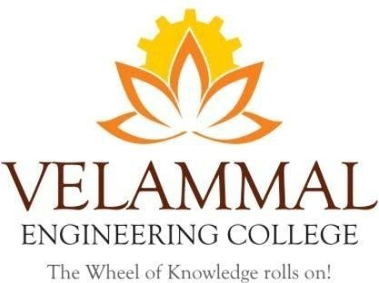

Guest Lecture on "Innovation and Entrepreneurship: A Pathway to Career Success"

For 1st Year B.E / B.Tech Students

Organized By

DEPARTMENT OF

## PHYSICS

SUBMITTED TO

ENTREPRENEURSHIP DEVELOPMENT CELL LEMON IVY

### VELAMMAL ENGINEERING COLLEGE

**(An Autonomous Institution)**

# Department of Physics

1. Title of the Event : Guest Lecture on "Innovation and Entrepreneurship: A Pathway to Career Success" for 1st Year B.E / B.Tech Students
2. Resource Person **: Nil**

3. Date : 28-11-2024

1. Session Type : Offline
2. Program Type : Oral presentation
3. Annexure- I : List of Participants
4. Annexure- II : Brochure
5. Annexure- III : Photographs
6. Annexure- IV : Participants Feedback

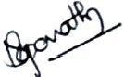 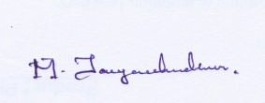

|  |  |
| --- | --- |
| **Dr. M. Jayachandiran** Assistant Professor Event Coordinator  Department of Physics | **Dr.S.Shahil Kirupavathy** Professor & Head Convener  Department of Physics |
|  |  |

### ANNEXURE-I

**Table 1: List of Participants**

|  |  |  |  |  |  |  |  |
| --- | --- | --- | --- | --- | --- | --- | --- |
| **S.No** | **Name of the Student1** | **S.No** | **Name of the Student2** | **S.No** | **Name of the Student3** | **S.No** | **Name of the Student3** |
| 1 | ABDULLAH SHEIK SAMEER M | 18 | NIRANJAN S | 35 | DHANUJA N A | 52 | ROSHINI P |
| 2 | AKSHAY R | 19 | PRASHANNA K M | 36 | GLENYS R | 53 | RUKMANI D |
| 3 | AKSHAY S | 20 | RAVI BALAJI T | 37 | GURUDHARSHINI A | 54 | SAI PRIYA M R |
| 4 | ANBARASU A | 21 | RAVIVARMA. S | 38 | HARIN SHEKINA D | 55 | SHARNIKA M |
| 5 | BHARATH M | 22 | ROHITH VALLEPU | 39 | HARINI. G | 56 | SRISHA E |
| 6 | DHIVAKAR K | 23 | SABARISH B | 40 | HYNDHAVI C | 57 | SUBA SRI S |
| 7 | DIVAKAR S | 24 | SACHIN V | 41 | JESSICA JUNIPER | 58 | HARINI. G |
| 8 | GODWIN M S | 25 | SAKTHIKUMAR R | 42 | KAMALIKA V | 59 | MADHUMITHA K |
| 9 | GOKUL PRASAD S | 26 | SANTHOSH M | 43 | KARUNYA VALLI NACHI T | 60 | PREETHA N |
| 10 | HARISH SHANKARA RAJA G | 27 | SANTHOSH P | 44 | MADHUMITHA S | 61 | Dr.J.Arumugam |
| 11 | HARRSHAN S | 28 | SANTHOSH. V | 45 | MAHASWETHA B | 62 | Dr.M.Jayachandiran |
| 12 | JAI AAKASH K | 29 | SRIRAGUL S | 46 | NEDHIYA FATHIMA.S | 63 | Dr. Vinoth Kumar |
| 13 | KARTHIKKAYAN V | 30 | VIGNESH M K | 47 | PARUVATHY SP | 64 | Mrs. Hamsavalli |
| 14 | LOHITH V | 31 | ANNE SHERIN. S | 48 | PAVITHRALAKSHMI S B | 65 | Dr.B.Sivatharani |
| 15 | MOHAMMED SYED ABUTHAHIR S | 32 | ARUNTHATHI M | 49 | PREETHA N |  |  |
| 16 | MOHAMED YOUSUF A | 33 | ASHMITHA A | 50 | RAKCITHA.U |  |  |
| 17 | MOHITHRAM MARUTHI N R | 34 | CHINDU PRIYAA L | 51 | REAVATHI V |  |  |

### ANNEXURE –II

### (BROUCHER)

**C:\Users\Dell\Desktop\1 event.tif**

*Figure 1: Poster for Guest Lecture on "Innovation and Entrepreneurship: A Pathway to Career Success"*

**ANNEXURE –III**

**Photographs**

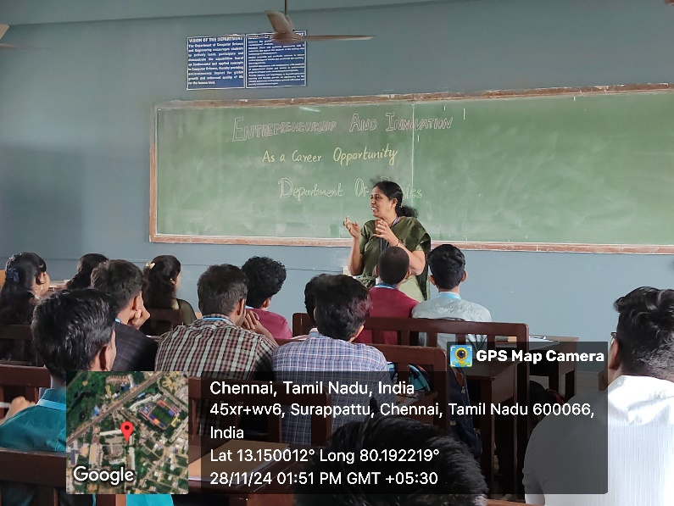

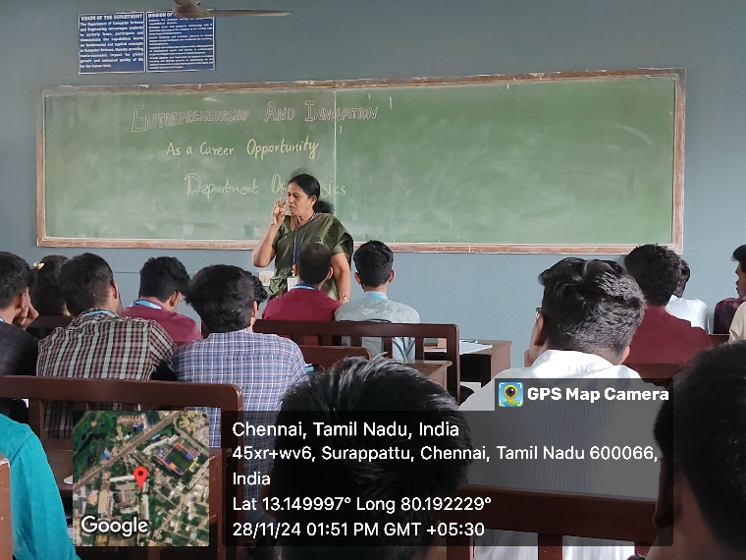

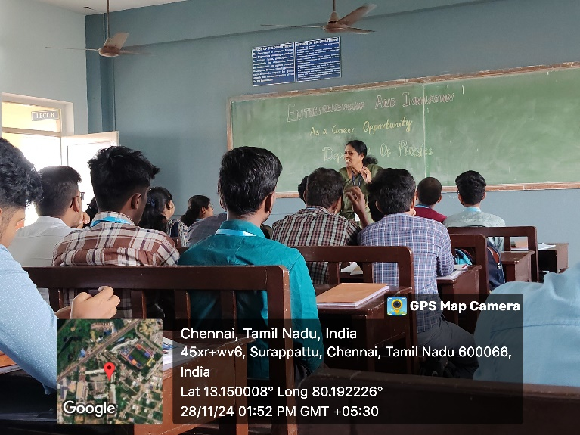

*Figure 2: Students are participate in the event : Guest Lecture on "Innovation and Entrepreneurship: A Pathway to Career Success"*

**ANNEXURE –IV**

**Table 2: Participants Feedback**

|  |  |  |
| --- | --- | --- |
| **Sl.No** | **NAME** | **How was the Guest Lecture on "Innovation and Entrepreneurship: A Pathway to Career Success"** |
| 1 | ANBARASU A | Very Useful |
| 2 | BHARATH M | Talent show case platform |
| 3 | PRASHANNA K M | Informative |
| 4 | RAVI BALAJI T | Excellent |
| 5 | RAVIVARMA. S | Superb |
| 6 | ROHITH VALLEPU | Helpful for future |
| 7 | SUBA SRI S | Inculcating research |
| 8 | HARINI. G | Good |
| 9 | MADHUMITHA K | Excellent |
| 10 | PREETHA N | Encourage Research ideas |